**TFTP Specifications:**

1. Server Port Number: 69 (not kidding)
2. Protocols: UDP and TCP; To be implemented in UDP
3. 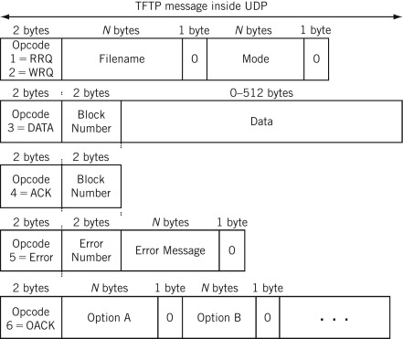
4. 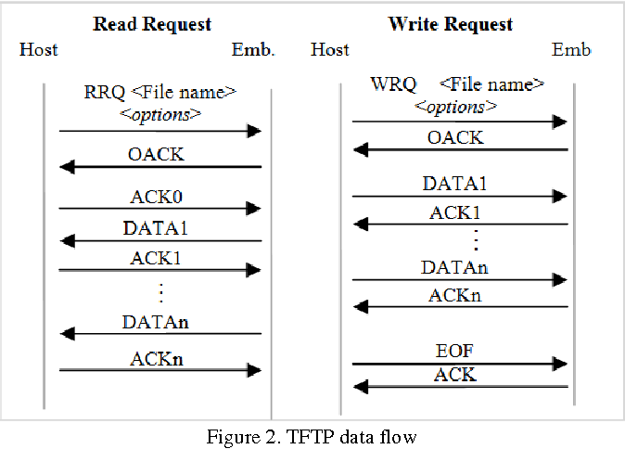
5. RFC 1350
   1. Overview of the protocol
      1. Connection Establishment:
         1. Any transfer begins with a request to read or write a file. This also serves as a request to connection.
         2. When granted by the server, the connection is opened with the file being sent in a fixed length blocks of 512 bytes.
      2. Transmission acknowledgement:
         1. Each data packet contains one block of data and must be acknowledged by an acknowledgement packet before the next packet can be sent.
         2. Any data packet sent with less than 512 bytes signals the termination of a transfer.
      3. Error Handling:
         1. Error packets are issued by both server and client when an error occurs on their side. This packet is however not acknowledged and not retransmitted.
         2. Timeouts are used to detect such a termination when the error packet has been lost.
         3. Error Events with Termination:
            1. Not being able to satisfy the request which are related to file availability/access or user availability.
            2. Receiving a packet which cannot be explained by a delay or duplication in the network (e.g., an incorrectly formed packet).
            3. Losing access to a necessary resource such as disk full or access denied during transfer.
         4. Error Events without Termination:
            1. The source port of a received packet is incorrect.
            2. An error packet will be sent back to the originating host if it does occur.
   2. Connection Protocol
      1. A transfer is established through
         1. A request to the target host. WRQ for writing (sending) or RRQ for reading (receiving).
         2. A positive reply.
         3. An acknowledgement packet for write or the first data packet for read.
         4. Each end of the communication should choose a port identifier for itself throughout the duration of that connection (i.e., normal UDP pre-operations from Lab4).
      2. Overview of ACK packet: It will contain the block# of the data packet being acknowledged.
      3. Transfer
         1. Read & Write
            1. Each data packet is associated with a block number.
            2. Block numbers are in consecutive order.
         2. Write: The initial block# will be 0 since it begins as an ACK packet rather than a data block.
      4. Error ACK: If the reply is an error packet, the request will then be denied.
6. RFC 2347
7. RFC 2348
8. RFC 2349